**Handout A-2**

**Environments**

**Picture 1**

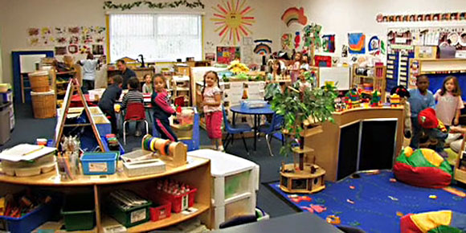

Credit: NAEYC.org

**Picture 2**

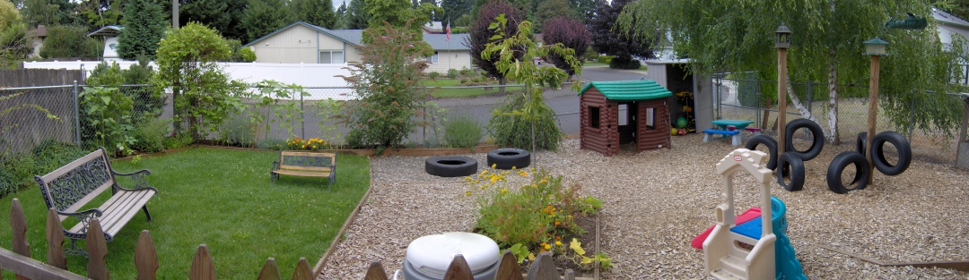

Credit: Vancouver Montessori

**Picture 3**

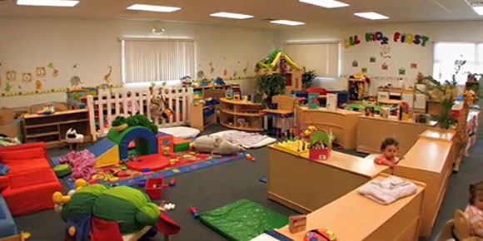

Credit: Allkidsfirstnj.com

**Picture 4**

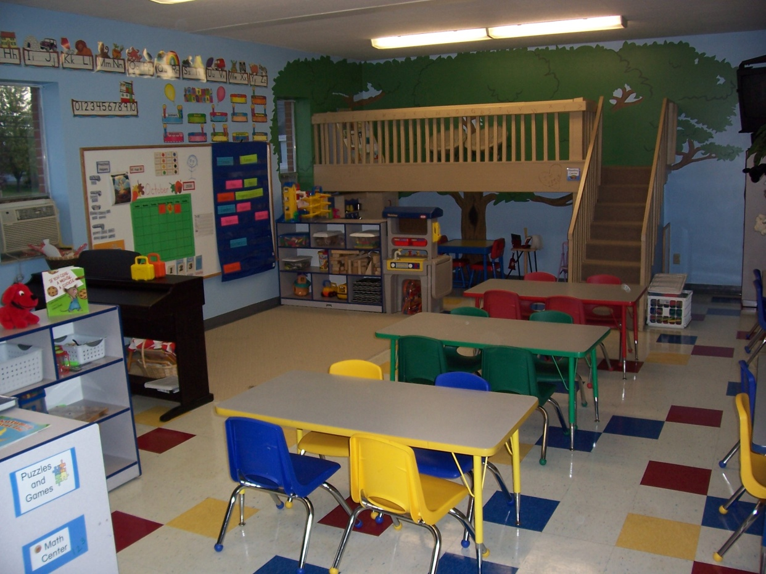

Credit: beautifulsavior-gc.net

**Picture 5**

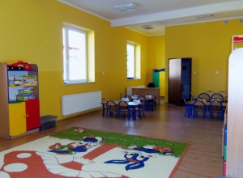

Source: teachthemdiligently.net

**Picture 6**

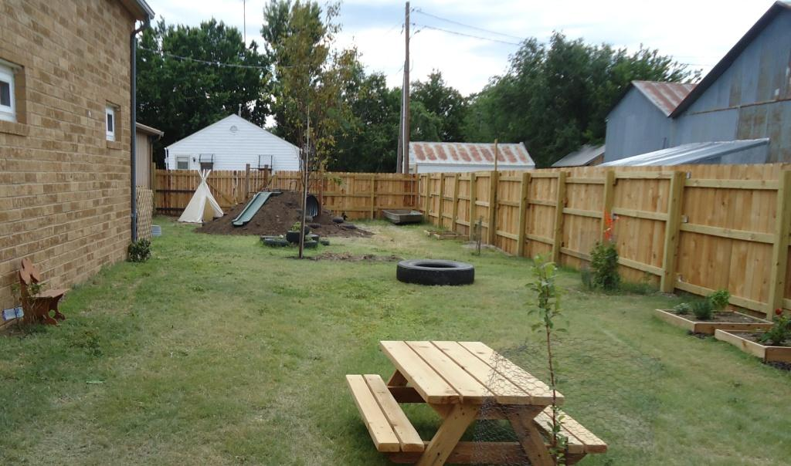

Credit: childcarecenter.us

**Picture 7**

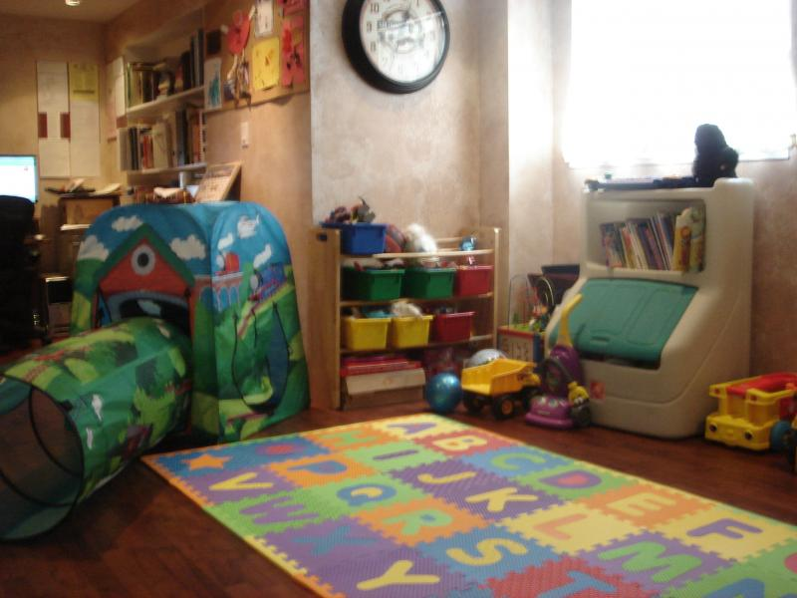

Source: Small Wonders Family Child Care

**Picture 8**

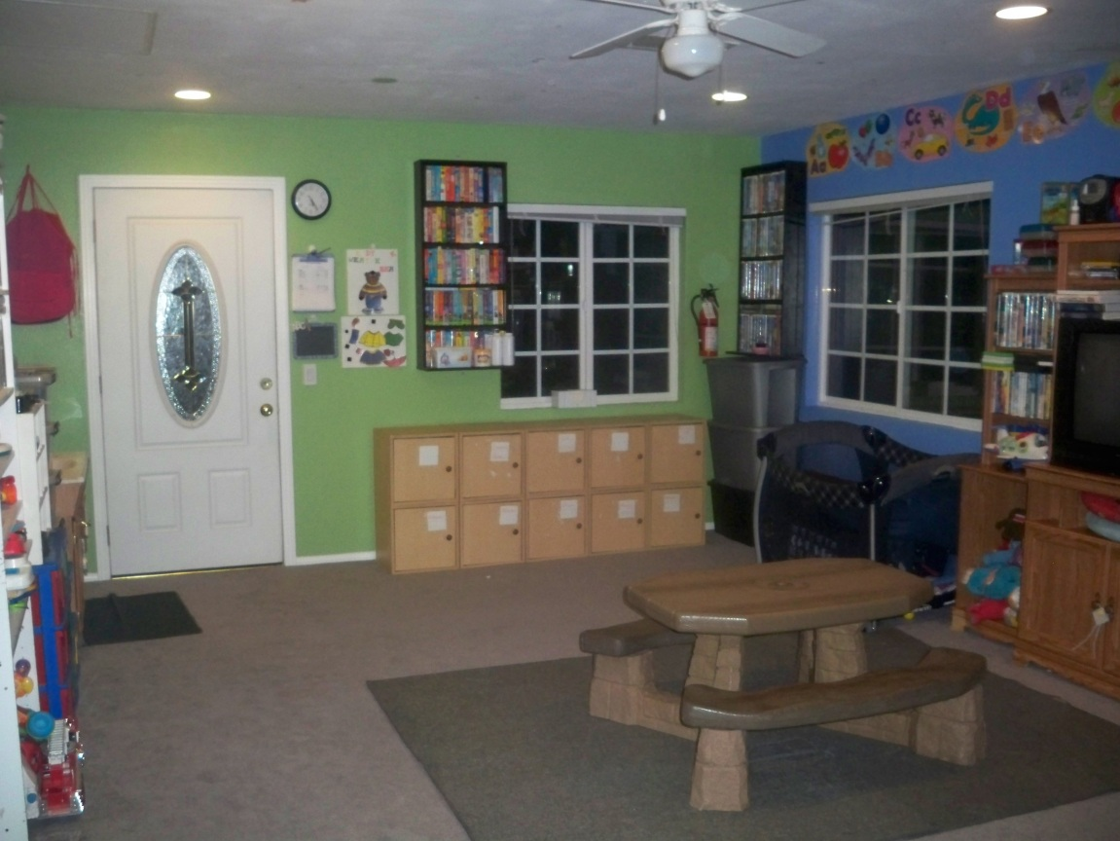

Source: Harris Family Child Care

**Handout A-3**

Looking at Safe, Appropriate Environments

Name______________________________________________Per______Date____________

**Using the photos on Handout_, answer the following questions:**

**Picture #_________**

1. Which age group do you think this environment serves?
2. What five elements about the environment do you find most appealing to that specific age group?
3. What would you change if this were your classroom or childcare center? Why?
4. How many interest areas or leaning centers do you see in the photo?
5. Do you believe the environment is inviting *and* safe, based on the picture? Explain.

**Picture #_________**

1. Which age group do you think this environment serves?
2. What five elements about the environment do you find most appealing to that specific age group?
3. What would you change if this were your classroom or childcare center? Why?
4. How many interest areas or leaning centers do you see in the photo?
5. Do you believe the environment is inviting *and* safe, based on the picture? Explain.

Looking at Safe, Appropriate Environments, cont.

**Picture #_________**

1. Which age group do you think this environment serves?
2. What five elements about the environment do you find most appealing to that specific age group?
3. What would you change if this were your classroom or childcare center? Why?
4. How many interest areas or leaning centers do you see in the photo?
5. Do you believe the environment is inviting *and* safe, based on the picture? Explain.

**Picture #_________**

1. Which age group do you think this environment serves?
2. What five elements about the environment do you find most appealing to that specific age group?
3. What would you change if this were your classroom or childcare center? Why?
4. How many interest areas or leaning centers do you see in the photo?
5. Do you believe the environment is inviting *and* safe, based on the picture? Explain.